Core|Personnel: User Defined Fields

Contents
Document Version Control 1
Approved process for raising 2
Consultation & Approval 2
Change Management 2
How to 3
Testing 7
Communications 7
Downstream Systems & Processes 7
Affected Reports 7
Additional Background Information 8

Document Version Control
Change History/Review Details
Date | Version | Review by | Summary of Change
03/07/15 | 0.1 | Simon Burford | Draft Created
06/07/15 | 0.2 | Joanna Davies | Minor amendments to draft
16/02/18 | 0.3 | Helen Child | Content updated for clarity, Detailed ‘How to’ steps moved to How To guide
16/12/20 | 0.4 | Helen Child | Updated following implementation of V28 in the Portal
27/03/25 | 0.5 | Simon Burford | Updated relating to the data warehouse

Approved process for raising
Does the change need to be raised through a particular route or by a particular person/team? Are there any actions which need to be taken or considered prior to processing in the HRIS Support Centre?
The requirement for a UDF will often come from a Business requirement, so the Business Process Advisor within the HRIS Support Centre will usually lead on gathering requirements for a new UDF.

A “MASTER UDF Template” excel file is stored in the following folder which should be completed, usually by or with assistance from an HRIS Analyst, outlining how the UDF should be set up within the system:
P:\PROJECTS\HRIS Programme\12. Support\Reference Data\UDFs

Completed UDF templates should be saved within a sub-folder named to reflect the UDF to be set up. Any changes to the template during the process (see Change Management section) should be saved within this sub-folder.

Consultation & Approval
Who is the owner of this information? Who needs to be consulted about this change before you begin work on it? Does anyone need to approve this change before it is implemented?
New UDFs and changes to existing UDFs are generally requested by the relevant business area, often within Personnel Services. The HRIS Business Process Adviser will usually lead on/be involved in the consultation and gathering requirements for both new UDFs and changes to existing UDFs.

The Change Request will be approved by the relevant approver in OSM – usually the Head of HRIS or their nominated deputy.

You must give early notification of the intention to change a UDF or create a new UDF to the HR Analytics team, or HR Systems Analysis and Insights Manager, to consider the impact on the data warehouse.

Change Management
What type of change is this? When should approval be sought and from whom (internal to team or change manager)? Who would normally be responsible for implementing?
New UDFs and changes to existing UDFs should be managed via the Change Request process in OSM.

New UDFs could be a candidate for a Standard Change but this needs to be discussed and agreed.

If during the course of the build or testing process any requirement for changes to the UDF are identified, the template should be amended and saved (with a new version number) in the UDF folder. Only the latest version of the UDF Template should be attached to the Change Record, so previous versions may need to be removed (if possible).

How to
Technically how to process the change in the system
Adding a new UDF
UDFs are ‘forms’ that can be used to store additional information which cannot be recorded anywhere else in the Personnel module. There is a standard template that cannot be altered although the field descriptions and content can be configured.

UDFs can be held at Appointment, Person (employee) or Recruitment level. This is determined via the Advanced settings when creating a UDF.

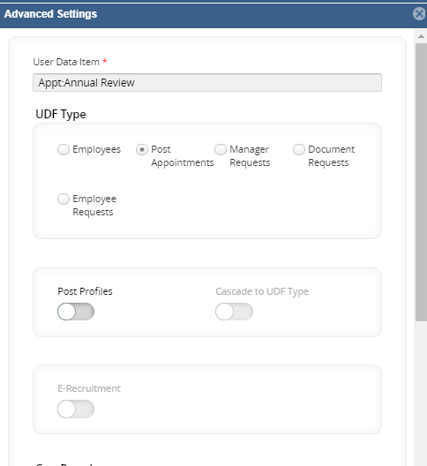

Person and Appointment level UDFs are accessed within the employee record in People Management in the User Defined Field section. Recruitment UDFs are less common and relate to additional sections added to the online Application Forms. The Application Form with inbuilt supporting statement has one UDF and the Apprenticeship Application form has three. These provide additional sections that could not be included any other way.

Each UDF is assigned a Reference Code and Description when it is first created.

  - The reference code is restricted to 6 characters (alpha). It is used for reporting purposes to identify the relevant data items. It is not displayed in the UDF.

  - The Description is displayed within the UDF in the Select Detail or Selection menus as applicable. There is a 40 character limit for the Description.

There are 12 Fields available. Each field can be configured as a List item (LoV), Text (free text field), or Date. (There are other options but we don’t use them.)

UDFs are configured in the Portal via People Management > HR Admin Setup Settings > User Defined Objects.

The User Description (Data Label) is displayed against each input field in the UDF and appears in the UDF as shown below:

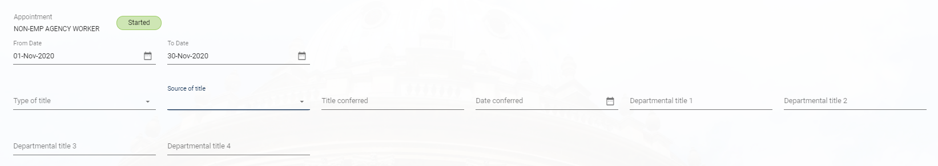

Data Type determines what can be entered into that field. E.g Date, text, list item

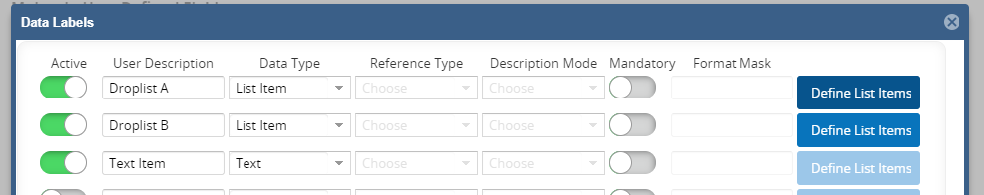

List items form a drop-down list that can be selected within a field in the UDF.

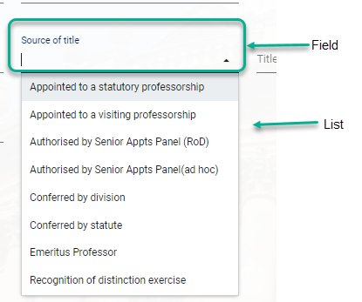

The data items are stored in the database table under the Item number and not the field description/label. For example ‘Inducted By’ will be stored under Item 3 in the database. This causes issues when User Descriptions or Field Items need to be amended.

Full details on creating a new UDF can be found in the How To guide.

Changing a UDF
Making amendments to UDFs is technically straight forward; However, great care must be taken as existing data will not automatically feed through to the data which has already been entered. This is because data is entered against an Item Number generic across all UDFs rather than against a field specific to that UDF. Please read the information below before proceeding.

Adding a new List Item to an existing list
Adding a new List Item to an existing list will not have any impact on existing data.
You can also amend the order in which the list items are displayed by re-entering the entire list or swapping items around.

Editing existing List Items:
Any changes made will apply to all existing records where the edited field(s) have previously been selected. However the UDF itself will not update automatically on the individual records and an error message will be displayed whenever the UDF is opened. To correct this the individual UDF records must be updated to re-select the edited item. This is a manual process as each UDF needs to be opened within every affected employee record, the updated field(s) reselected and the changes saved.

For this reason changes can only be made with agreement from all affected parties and where a plan is in place to correct the employee records.

List Items - The preferred approach is to add a new list item, update the affected records to select the ‘new’ list item and then untick the active indicator against the ‘old’ list item.

Example:
Right to Work List item ‘EEA Family Permit’ was changed to ‘EEA Family Permit (6 months)’ in Jan18. A new list item was added for the new description, the affected employee records were updated to select the ‘new’ description and the ‘old’ list item showing the previous description was made inactive.

Editing existing Field items:
Any changes to the Description will apply to all existing records where the edited field(s) have previously been selected. Unlike the List items the Field items will update automatically and no changes will be required to the individual records. However, any reports containing the edited UDF will need to be updated as the column headers will refer to the previous Field Item Description.

Removing Field Items or changing the order in which they are displayed
Due to the way in which the items are stored in the database i.e. against the item number not the User Description, this is not a straightforward change and has the similar limitations to editing field items.

Depending upon the number of changes and the number of affected records you may need to consider creating a new UDF and migrating the data via the Data Upload tool available in the Core Portal.

For this reason changes can only be made with agreement from all affected parties and where a plan is in place to correct the employee records.

Removing List Items
You can remove items from the list of values by making them inactive, or by deleting the item and if necessary re-ordering the list. However, any user data which has already been entered using the deleted list item will not be correct but will not display an error message.

For this reason list items can only be deleted with agreement from all affected parties and where a plan is in place to correct the affected employee records.

Changing where the UDF appears
If you need to change where the UDF is displayed (i.e. from Appointment to Person) it is possible to simply change the tick box under the Advanced tab. However any new records created after the change will appear in a different table so any user data entered against the previous position will not be visible in the new position. The historic information will not be lost but you will be unable to view it in the back office unless you keep the old “position” ticked, which will cause confusion.

Therefore, depending on the change required, it may be better to set up a new “replacement” UDF in the new position and then remove the old UDF from use (following the “Removing a UDF” steps).

If you need to transfer historic data from the old version of the UDF into the new version this can be done via the Data Upload tool in the Core Portal – refer to HOW TO Prepare Data for the Data Migration Tool

Removing a UDF
Removing a UDF with no user data entered
If no user data has been entered against a UDF you are able to delete the row from the User Defined Fields screen.

Navigate to: People Management > HR Admin Setup Settings > User Defined Objects.

Standard Icons & Terminology
Standard Button Names  Enter Query Mode button:  Previous Record button:   Previous Section button:   Save button:   Insert Record button:  | Execute Query button:   Next Record button:   Next Section button:   LOV button:   Delete Record button:  | Cancel Query button: 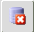  Red Door button: 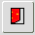  Duplicate Record button: 
Navigation Paths

Show the final navigation path option in bold +italics, for example;

Core|Personnel > Reference > Reference A – C > Accident Codes
Core|Pay > Reference > Pay Groups

Any further navigation beyond the navigation path can be added after an ellipsis (…), for example;

Event Management > Event Configuration … HR Events > Change of Address

Testing
Who would normally be responsible for testing? Are there standard items to test?
Normally the HRIS Business Analyst or HRIS Process Team would undertake user acceptance/functional testing, although this may also be done by end users depending on which groups of users will be expected to use the report.

Communications
Who needs to be informed (but not consulted) about this change? Detail when they should be informed (before or after the change).
The Right to Work UDF is used in an interface so the ‘SSM – Business Integration Technologies Team’ within Software Solutions will need to be informed of any potential changes to this UDF ahead of any work being done – see Downstream Systems & Processes.

It is likely that user communication will be required, particularly with a new UDF, depending on who the target audience of the UDF will be. As UDFs are normally raised through the Process Team or Business Analyst, training guidance and communication will normally be considered and taken care of.

Downstream Systems & Processes
Details of any processes which are affected or need to be carried out following, or as part of, the change. Please detail any triggers, actions required and when the actions should be carried out.
Data Warehouse
Most UDFs are migrated into the Data Warehouse and split out into individual tables according to their code. There are then views built which translate the underlying columns (text1, text2 etc) into their actual headings. If you are changing the structure of a UDF (introducing a new field, changing the heading) there will be changes required to the warehouse. If you are replacing a UDF with a new version with a new name then all of the tables in the warehouse will need to be rebuilt. You must inform the HR Analytics Team, or the HR Systems Analysis and Insights Manager, of the changes being made.

Interfaces
UDFs are rarely used within interface files but information in the Right to Work UDF is taken by the following interfaces:
- CoreHR to Access Databases ‘staff including casuals’ interface (Interface Staging PROGID_170), which sends email to HRIS Support with subject lines following this pattern: Interface Staging: req=hris/pcapps/staff ref=%ID% status=SUCCESS.
- CoreHR to EAP interface (Interface Staging PROGID to be confirmed), which sends Right to Work data for all staff to the Examiner Appointments and Payments system, transforming the CoreHR data into “Right to Work = TRUE/FALSE” values.

NB!! Rules have been built into these interfaces to extract the data from the RTW2 UDF. Any proposed changes to the UDF or the description of the data labels within it will need to be fed back to the SSM-BITE team before the changes are made, so that the interfaces can be modified as necessary to continue picking up the required RTW information.

This is particularly important as UDFs are set up against generic Name/Description/Types, e.g. Reference Code, Item1, User Field1. Changes to the structure of a specific UDF need to be explicitly communicated to the SSM-BITE team so that they can ensure that the necessary parameters are in place in the interface to pick up the data from the modified UDF.

Affected Reports
Are there any standard reports which may need to be updated following this change?
There will almost always be reports affected by a change to a UDF as there is normally at least one accompanying report with that UDF. However this would depend on the UDF being updated as there is not one “UDF” report, rather they are reported on separately using the UDF “Reference Code” to only return data of a specific UDF type within any given report.

Any changes to UDFs (including moving from one UDF to another for the same purpose – e.g. ‘RTW’ to ‘RTW2’) will need to be reflected in the report. In a similar way to interfaces, the reports will still run but the data they return is likely to be out of sequence or not make sense if a report is not updated, and will therefore return inaccurate information.

Additional Background Information
Any other relevant information, links to supporting documentation etc.
Right to Work Interface Emails

From: Joseph Harris (IT Services)
Sent: 03 July 2015 12:19
To: Simon Burford; Mandy Zaccheo
Subject: RE: Right to Work in Core

Hi Simon,

… We’ll want to write a function on the Staging side to derive the least possible information required by NomCom; will need to work to Amanda to establish what that is.

“Could you please let me know what you would refer to as the name of the interface? So that when we contact you about this in the future we’re talking your language and you know exactly what we’re talking about? I assume that you’re only going to be pulling RTW data into one interface?”

Yes, so this is going into Interface Staging PROGID_170, the CoreHR to Access Databases ‘staff including casuals’ interface, which sends email to HRIS Support with subjects lines following this pattern:
Interface Staging: req=hris/pcapps/staff ref=%ID% status=SUCCESS

The interface loads shared Access databases/files [pending move to SQL server, a project which is in its infancy]. The RtW flag or flags will only be propagated to NomCom.

The current functional spec is available on SharePoint here:
https://sharepoint.nexus.ox.ac.uk/sites/itservices/integration/Support/INT-STG/_layouts/WordViewer.aspx?id=/sites/itservices/integration/Support/INT-STG/SSM%20Documents/HRIS%20to%20Access%20%28staff%29%20Interface%20Func%20Spec.docx&Source=https%3A%2F%2Fsharepoint.nexus.ox.ac.uk%2Fsites%2Fitservices%2Fintegration%2FSupport%2FINT-STG%2FSSM%2520Documents%2FForms%2FFunctional%2520Specifications.aspx&DefaultItemOpen=1&DefaultItemOpen=1

(Most of these specs have been left in the project folders – I moved just this one to our SharePoint since I own the target system and therefore the spec document. At least, I think so.) Let me know if you can’t access it and I’ll ask David Hickman to add you; I’ll update this with details of the new flag or flags when we’ve figured out the business rules.

So, yes, only one interface, the interface into Access databases which includes Casual Staff, with the new fields to be used only by one Access database (fed indirectly from the repository data).

